

**SCHOOL OF COMPUTING**

**UNIVERSITI UTARA MALAYSIA**

**STIA1113 PROGRAMMING 1**

**PROJECT (30%)**

**FIRST SEMESTER SESSION 2019/2020 (A201)**

PROJECT 1 STIA1113 GROUP H COMMUNICATION

MEMBERS NAME:

|  |  |  |
| --- | --- | --- |
|  | **NAME** | **MATRIC NUMBER** |
| 1. | NUR FATIN NASUHA BINTI SHAMAS | 278062 |
| 2. | NG ZI HENG | 278024 |
| 3. | NUR FARAHANIM BINTI MAT AMIN | 277863 |
| 4. | MUHAMMAD SHAKIR ZUFAYRI BIN MOHD RAZINI | 277980 |

Date of Submission :

**CONTENTS**

|  |  |
| --- | --- |
| TITLE | PAGE |
| 1.0 BACKGROUND OF THE PROJECT | 3 |
| 2.0 UML CLASS DIAGRAM | 5 |
| 3.0 PROGRAM DESCRIPTION | 6 |
| 4.0 THE CODE | 31 |
| 5.0 THE SAMPLE RUN | 47 |

## 1.0 BACKGROUND OF THE PROJECT

For STIA1113 Group Project, our project is to establish a system or an application for the communication store. In our communication store have 4 store/shop for user to choose. There is internet store, mobile phone store, laptop store and last but not least, TV store.

First of all, we create our project details with bring up the address and location of our store. Number phone, our store ID, link online to our store and others. Data below shown are our store data and details to the user information.

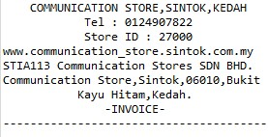

Next, Internet store will have a lot of package for user to choose like daily pass, weekly pass, monthly pass and top up. Our project it is easy for user to choose on what they want to pick and select their choice. In our project, for each of our store. The user needs to input some of their personal information and data before proceeding to the next session. Here are the data package of the internet store.

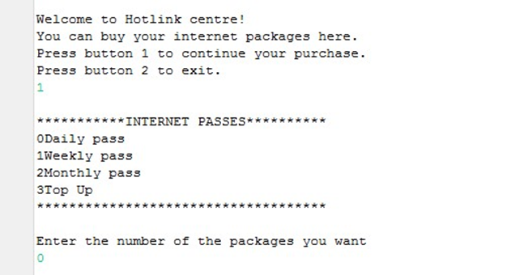

Then, the mobile phone store also provides many types of mobile phone for users to choose and buy. Here a type of mobile phones that the store sell:



Next, for the laptop store, the store for sure its easy to users to interact with such a simple and nice store to be looking around the product and also the price of this laptop store. Here the brand and the best quality of the laptop, in Laptop Store:

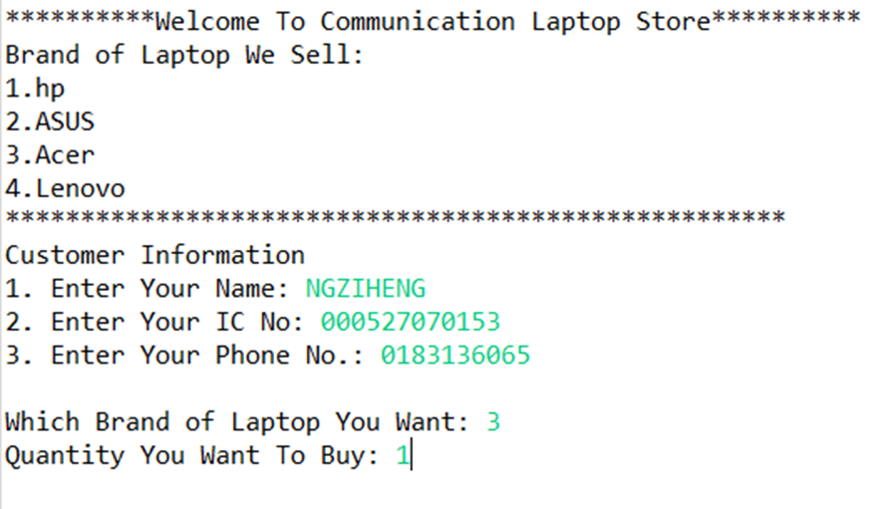

Last but not least, the TV store also provide a blast promotion and discount, of course. The best quality of the product will drag in the users to buy and some attractive things to give to the users, when buy and the TV store:

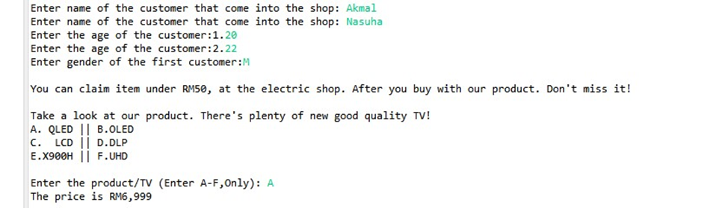

Also, user can proceed with the orders in our communication store with an easy select. After the orders done, our project will immediate execute the total and data for user to pay. Lastly, our store will show the message and output to the user at the last of our coding. The messages are when our store will close? Then, minimum spend for the next visit also the user can submit their feedback through the link address given. At the end of the messages, given the ‘Guest relations centre’ for user to contact, if there is any problem during the process.

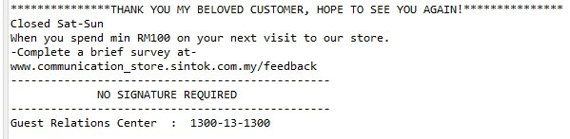

## 2.0 UML CLASS DIAGRAM

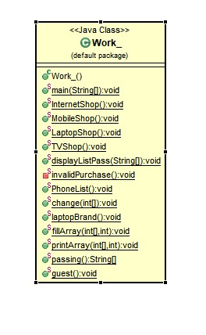

## 3.0 PROGRAM DESCRIPTION

In program description, we will explain how to use our application for the user in the future.

1. Coding of the introduction to our store, we also give some details of our store, (output). Next, the welcome and main selection to the store. In communication, we have 4 stores, (Internet, Mobile phone, Laptop and TV). So, the user will enter the number to go to chosen store.

For the main selection to other store, we are using the calling method and for user to select, we are using if else statement.

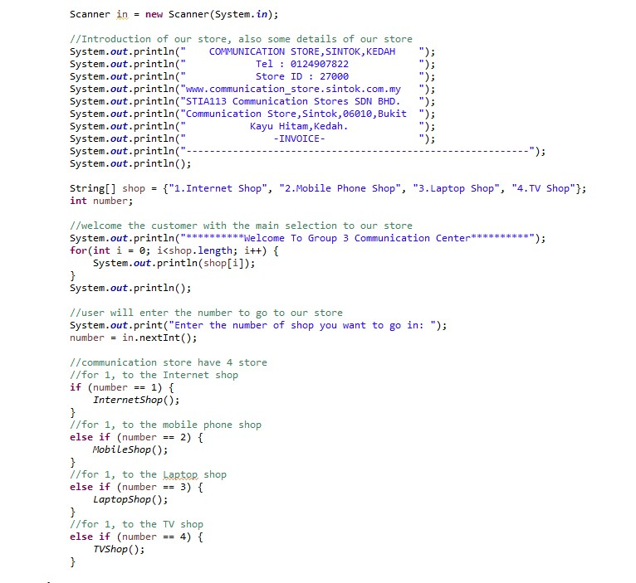

Output, details of the store and main selection to user :

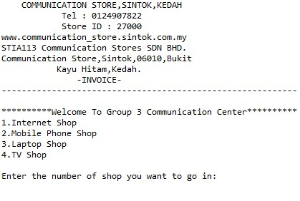

## Press 1: Internet Store

1. User press 1 for the Internet Store and user need to enter their details like name, IC number, phone number and also the balance. After the user input all the details, need to press 1 to continue or 2 to exit. Then, the coding will continue until the last of the first store of Internet.

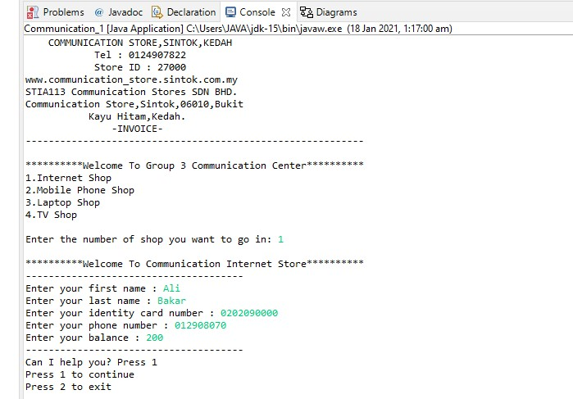

1. User need to enter their data such as name, identity card number, phone number, and balance. Then, to continue user has to press 1 or 2 to exit.
2. “Welcome to Hotlink centre!” will be displayed once user entered 1 to continue. And then user will be asked again to continue the purchase. So, user will need to enter 1 or 2 to exit.

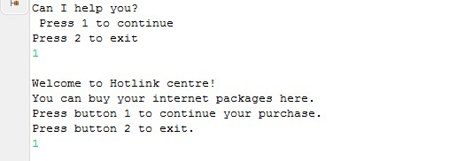

1. Then, menu will be displayed when user want to continue. From the menu, user will choose and enter the number of packages they want to buy.

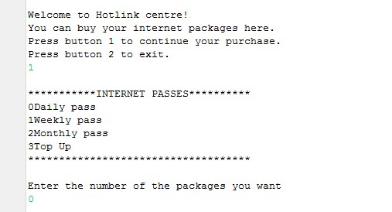

1. If user wants to buy daily pass, user has to enter number 0. Daily pass and its price will be displayed. So, user has to input 1 to confirm the purchase. Lastly, the statement of purchase will print user’s data, total purchase and current balance after price deducted from the balance.

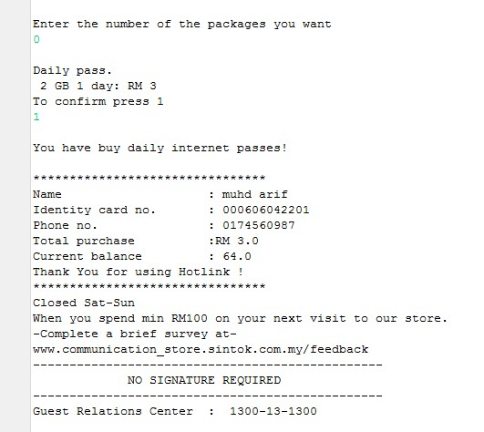

### Numerical data and expression

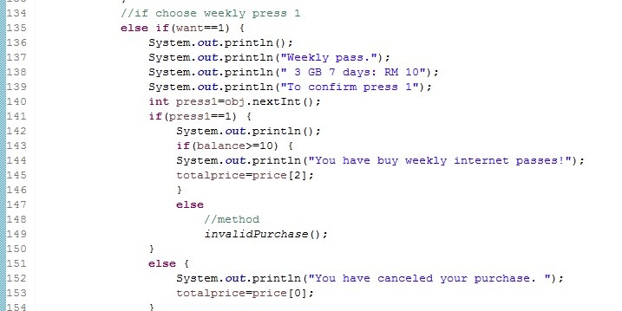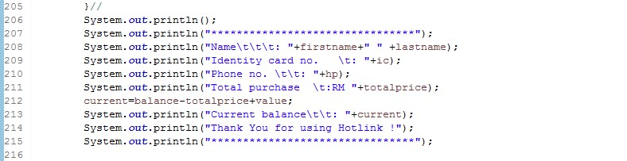

### Selection Control Structures

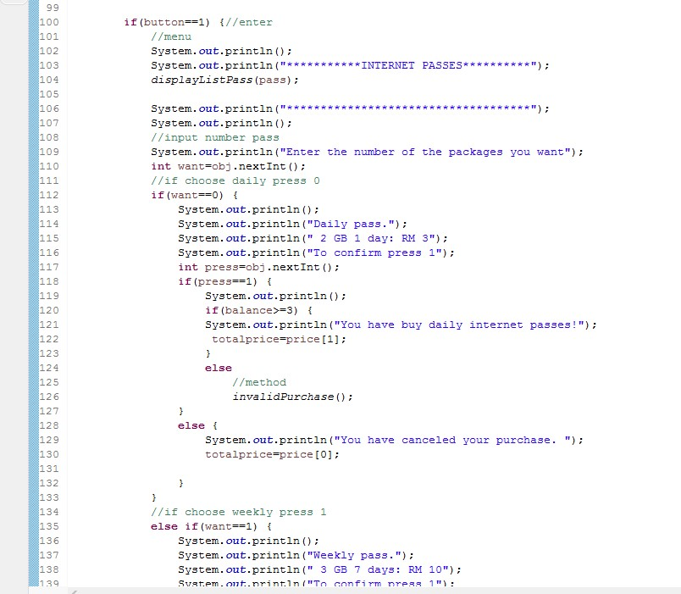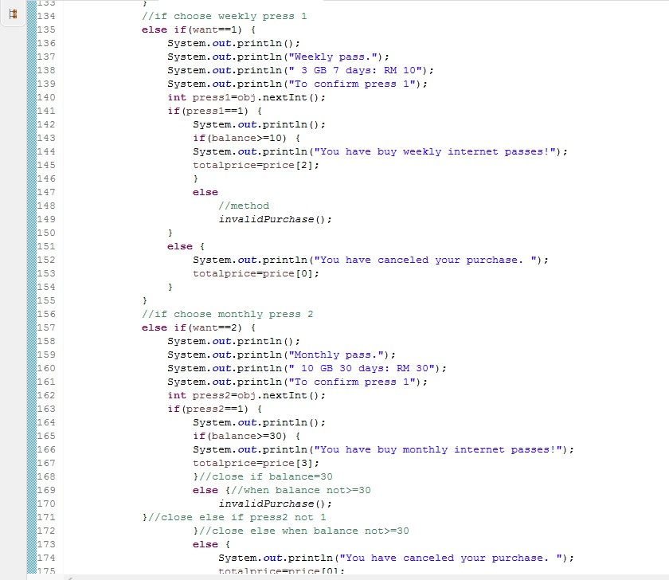

### Repetition Structure

**Array**

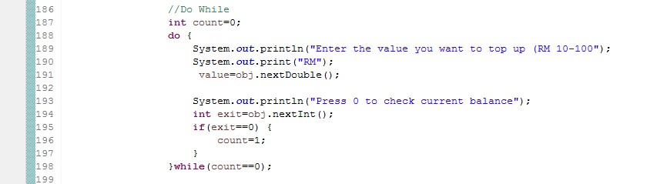

**Passing Array to method**

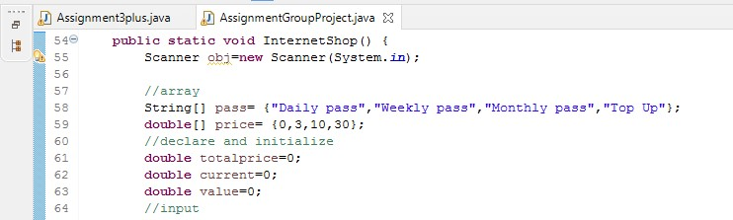

**Method**

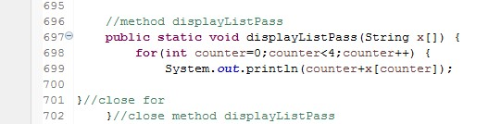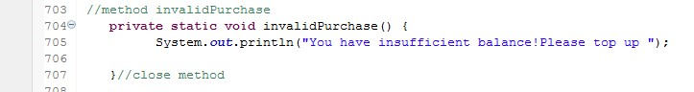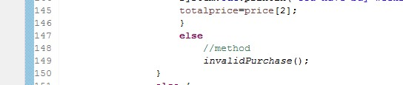

## Press 2: Mobile Phone Store

1. User press 2 for the Mobile Phone Shop and user need to enter their details like name, phone number and residence. Then, the coding will continue until the last of the first store of Internet.

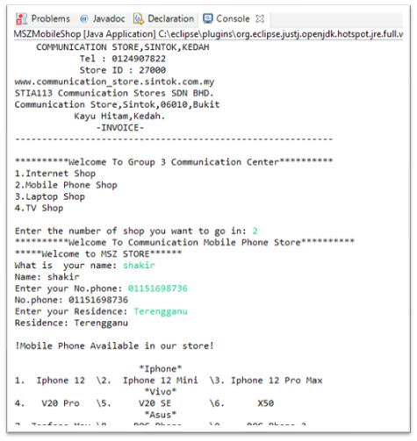

1. User need to enter their data such as name, phone number, and residence.

1. “Mobile Phone Available in our store!” will be displayed once user entered the data. Then user need to enter the number of phone in the phone list such as if u want Iphone 12 u must enter the number 1.

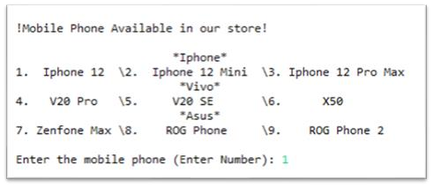

1. If user wants to buy iPhone 12, user has to enter number 1. After that, user must enter the quantity the phone what they want to buy in quantity purchase. Next, total price that user buying the phone and the price must user pay after the discount will be displayed.

1. Lastly, user can claim their free gift after buying such as cable phone, casing or tinted phone at the counter.

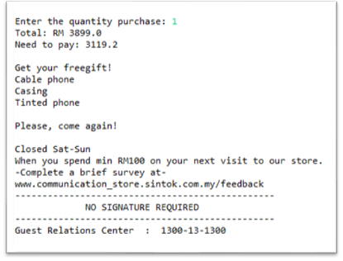

### Numerical data and expression

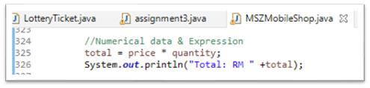

### Selection Control Structures

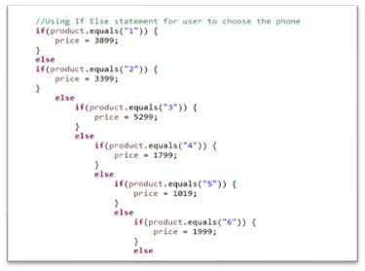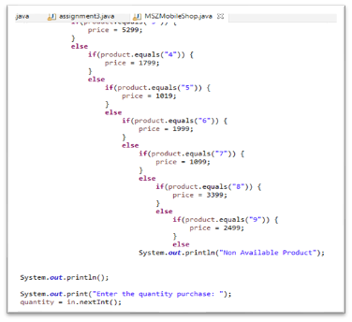

### Repetition Structure

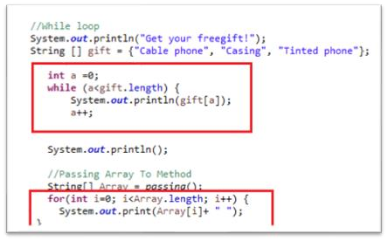

#### Array

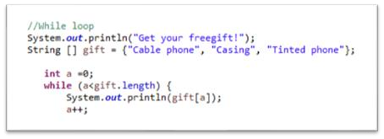

#### Passing Array to method

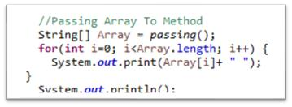

#### Method

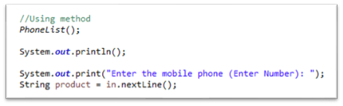

## Press 3: Laptop Store

1. When the users choose to press 3 to enter the Laptop Store, they will come into the Laptop Store and the program will show the brand of laptop that sell in Laptop Store.

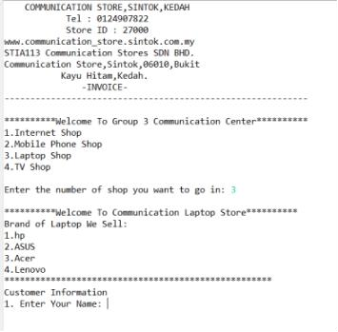

1. Next, users need to enter their information likes name, identity card number and contact number.

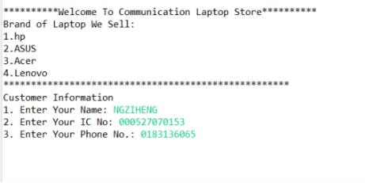

1. The program will ask the users what brand of laptop and the quantity they want to buy after they enter the customer information. For example, if users want to buy Acer this brand, users can just enter 3 to buy this laptop then enter the quantity they want to buy.

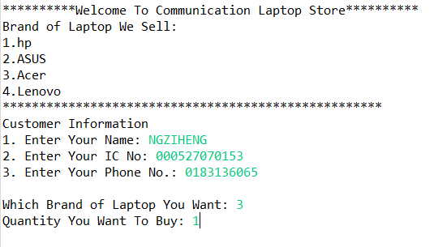

1. After that, if users want to buy another brand of laptop, they need to enter Y for yes when the program ask users want to buy another brand or not but if users don’t want they can just enter N.

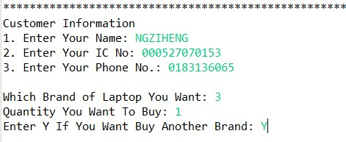

1. If the users choose to enter Y for yes, they will need to choose another brand of laptop and the quantity they want to buy.

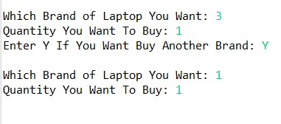

1. However, if user choose to enter N because they don’t want to buy another brand, the program will show the all the information of customer and accumulate the total price, discount, price need to be paid by customer and others information of our communication store.

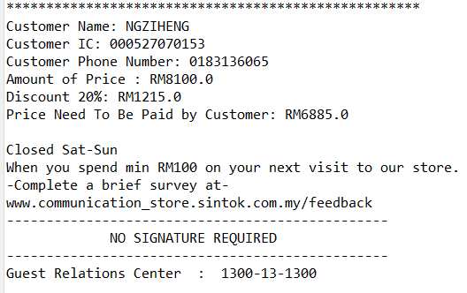

### Numerical Data and Expression

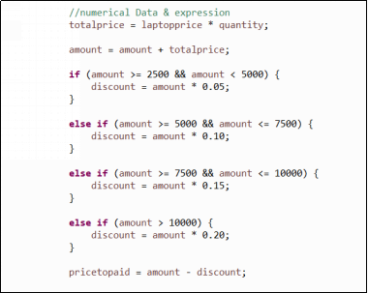

### Selection Control Structures

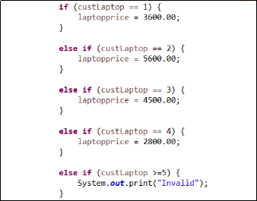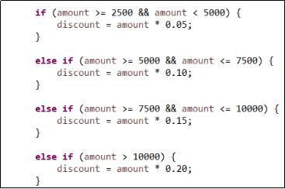

### Repetition Structure

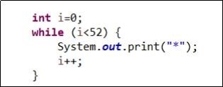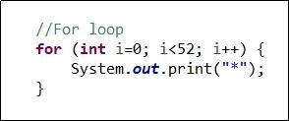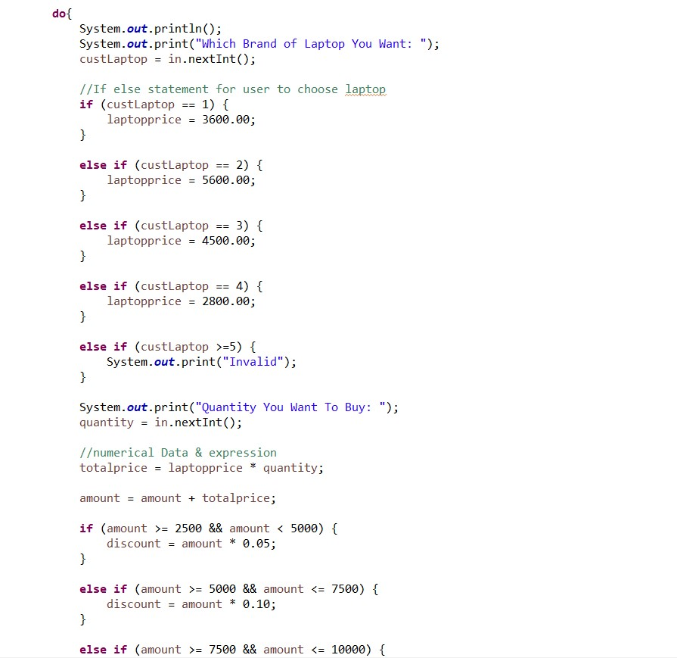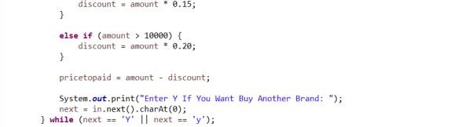

### Array

**Passing Array to Methods**

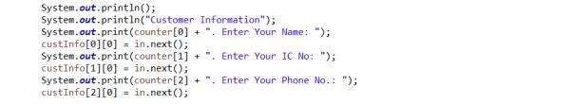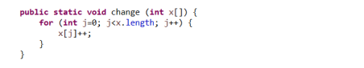

**Using**

**Methods**

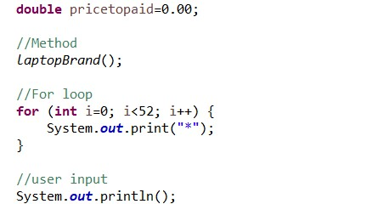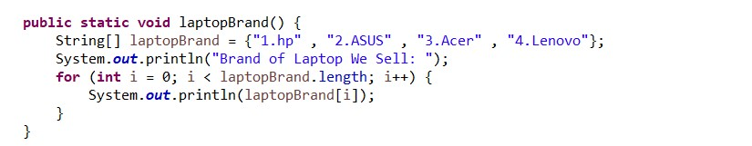

## Press 4: TV Store

1. After the users press 4 for the TV store, the store will display ‘Welcome’ greetings to the users and the program also display the personal assistant for the shop today. After the greetings, the program need the users to complete all the details.

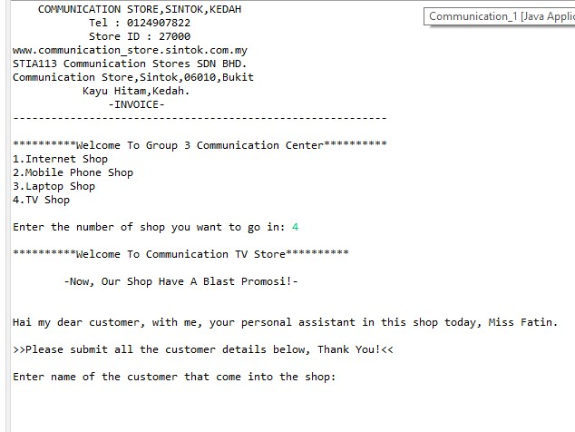

1. These are the details of the users need to enter and input before proceeding to other session. After the users enter the gender of the first customer that come into the shop, either F or M, will get item under RM50, at the Watson or electric shop.

For ‘F’, Female users, the program will execute item under RM50 at Watson:

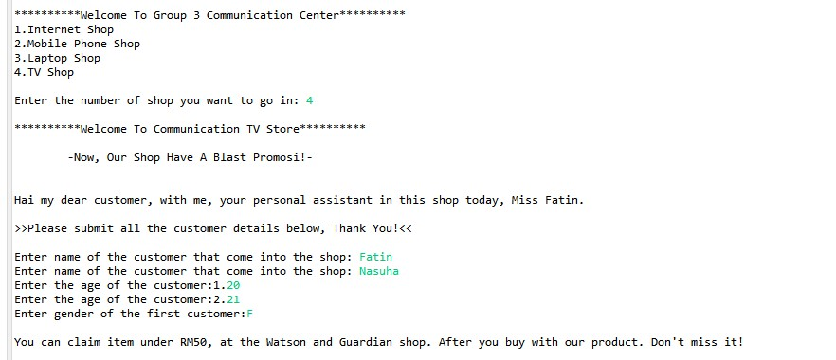

For ‘M’, Male users, the program will execute item under RM50 at electric shop

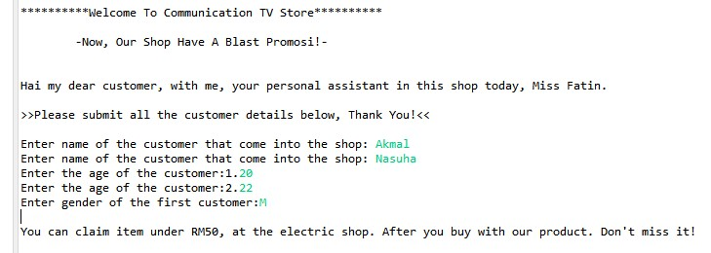

1. After that, the program will show all of the TV’s product, here inside this TV store are having 6 product, (QLED, OLED, LCD, DLP, X900H, and UHD). To choose on what users want for the TV’s product, users need to enter A-F only for the selection of the product they want. Next after the users enter the product, like example users want to pick QLED.

They need to enter ‘A’ and then, the program immediately will show the price of the QLED TV. Example below:

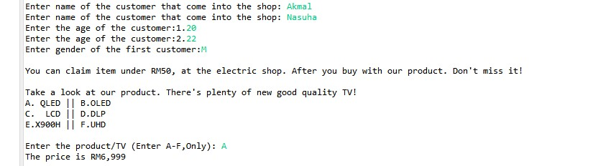

1. Here, at this time, the program will ask users to enter integer (1 until 4), it is for the limitation of the item when purchase on this TV store. So, the users will have their option to enter how many item that the users want to purchase.

After users enter quantity, program will ask users to enter the price once again, for the item that the users want to buy. Then the program will execute all the total price, calculate all the discount received for the users, and also give the users output of the price to be pay after discount. Programs show that delivery fee is free.

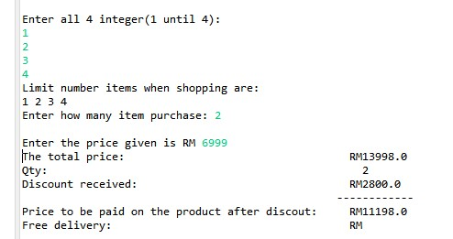

1. Then, program will ask users either the users want the store to deliver the items or not. Program will ask to press ‘Y’ for Yes or ‘N’ for No. If the users press ‘Y’. They need to fill in their address to deliver.

If users press ‘Y’:

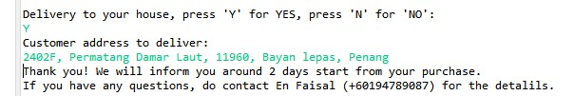

If users press ‘N’:



1. Last but not least, after the users submit all of the detail if they either want to delivery or not, program will output some messages like coupon to give for the users.

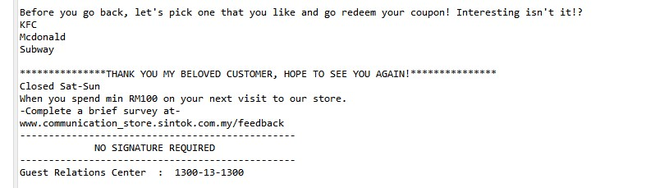

### Numerical Data and Expression

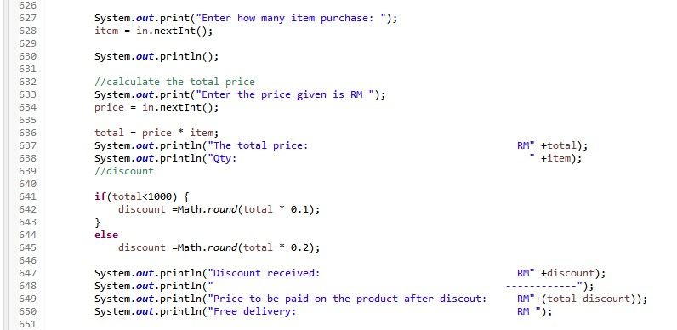

### Selection Control Structures

1. For selection of the product TV.

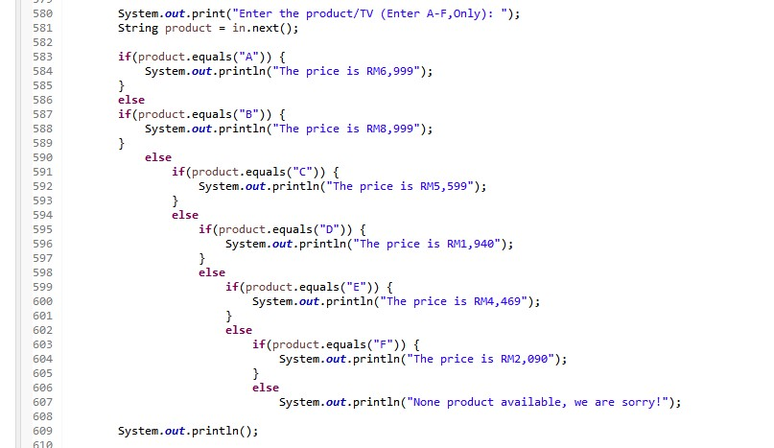

1. For selection of the gender users.

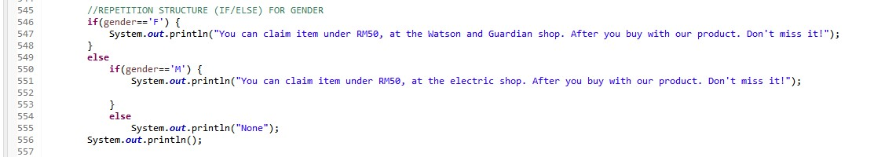

### Repetition Structure

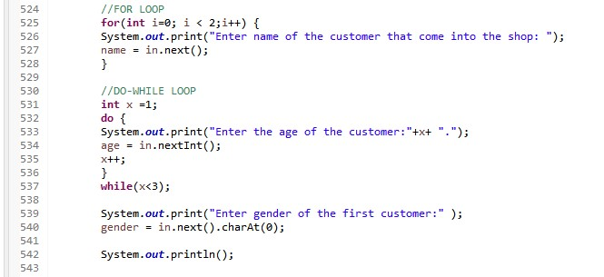

### Array

2D Array:

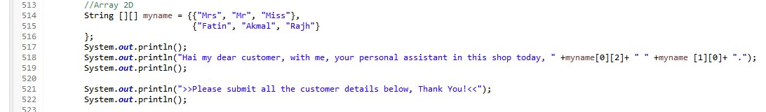

Single Array:

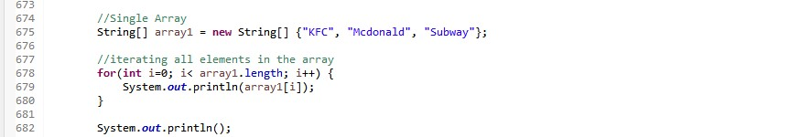

### Passing Array to Methods

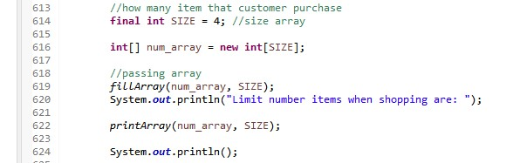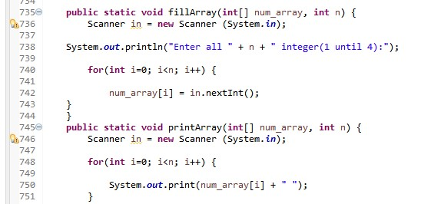

### Methods

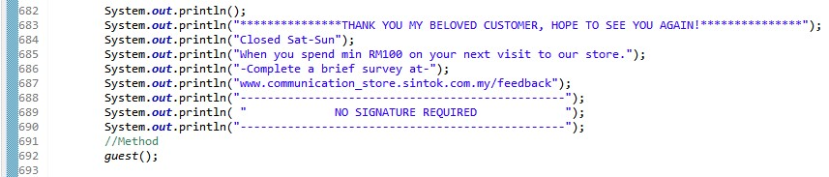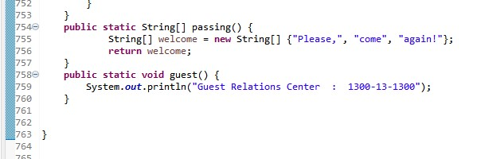

## 4.0 THE CODE

package Communication;

import java.util.Scanner;

public class Communication{

public static void main(String[] args) {

Scanner in = new Scanner(System.*in*);

//Introduction of the details of our store

System.*out*.println(" COMMUNICATION STORE,SINTOK,KEDAH ");

System.*out*.println(" Tel : 0124907822 ");

System.*out*.println(" Store ID : 27000 ");

System.*out*.println("www.communication_store.sintok.com.my ");

System.*out*.println("STIA113 Communication Stores SDN BHD. ");

System.*out*.println("Communication Store,Sintok,06010,Bukit ");

System.*out*.println(" Kayu Hitam,Kedah. ");

System.*out*.println(" -INVOICE- ");

System.*out*.println("-----------------------------------------------------------");

System.*out*.println();

//Array 2D

String[] shop = {"1.Internet Shop", "2.Mobile Phone Shop", "3.Laptop Shop", "4.TV Shop"}; int number;

System.*out*.println("**********Welcome To Group 3 Communication Center**********"); for(int i = 0; i<shop.length; i++) {

System.*out*.println(shop[i]);

}

System.*out*.println();

System.*out*.print("Enter the number of shop you want to go in: "); number = in.nextInt();

if (number == 1) {

*InternetShop*();

}

else if (number == 2) {

*MobileShop*();

}

else if (number == 3) {

*LaptopShop*();

}

else if (number == 4) {

*TVShop*();

}

}

public static void InternetShop() {

Scanner obj=new Scanner(System.*in*);

//array

String[] pass= {"Daily pass","Weekly pass","Monthly pass","Top Up"}; double[] price= {0,3,10,30}; //declare and initialize double totalprice=0; double current=0;

double value=0;

//input

System.*out*.println();

System.*out*.println("**********Welcome To Communication Internet Store**********");

//input

System.*out*.println("--------------------------------------");

System.*out*.print("Enter your first name : ");

String firstname=obj.next();

System.*out*.print("Enter your last name : ");

String lastname=obj.next();

System.*out*.print("Enter your identity card number : ");

String ic=obj.next();

System.*out*.print("Enter your phone number : ");

String hp=obj.next();

System.*out*.print("Enter your balance : ");

double balance=obj.nextDouble();

System.*out*.println("--------------------------------------");

System.*out*.println("Can I help you? ");

System.*out*.println(" Press 1 to continue"); System.*out*.println("Press 2 to exit ");

int c=obj.nextInt();

//If Else Statement if(c==1) {

System.*out*.println();

System.*out*.println("Welcome to Hotlink centre!");

System.*out*.println("You can buy your internet packages here.");

System.*out*.println("Press button 1 to continue your purchase.");

System.*out*.println("Press button 2 to exit.");

int button=obj.nextInt();

if(button==1) {//enter

//menu

System.*out*.println();

System.*out*.println("***********INTERNET PASSES**********"); *displayListPass*(pass);

System.*out*.println("************************************");

System.*out*.println(); //input number pass

System.*out*.println("Enter the number of the packages you want"); int want=obj.nextInt(); //if choose daily press 0 if(want==0) {

System.*out*.println();

System.*out*.println("Daily pass.");

System.*out*.println(" 2 GB 1 day: RM 3"); System.*out*.println("To confirm press 1"); int press=obj.nextInt(); if(press==1) { System.*out*.println(); if(balance>=3) {

System.*out*.println("You have buy daily internet passes!");

totalprice=price[1];

}

else //method

*invalidPurchase*();

}

else {

System.*out*.println("You have canceled your purchase. ");

totalprice=price[0];

}

}

//if choose weekly press 1 else if(want==1) {

System.*out*.println();

System.*out*.println("Weekly pass.");

System.*out*.println(" 3 GB 7 days: RM 10"); System.*out*.println("To confirm press 1"); int press1=obj.nextInt(); if(press1==1) {

System.*out*.println();

if(balance>=10) {

System.*out*.println("You have buy weekly internet passes!");

totalprice=price[2]; }

else //method

*invalidPurchase*();

}

else {

System.*out*.println("You have canceled your purchase. ");

totalprice=price[0];

}

}

//if choose monthly press 2 else if(want==2) {

System.*out*.println();

System.*out*.println("Monthly pass.");

System.*out*.println(" 10 GB 30 days: RM 30"); System.*out*.println("To confirm press 1"); int press2=obj.nextInt(); if(press2==1) { System.*out*.println();

if(balance>=30) {

System.*out*.println("You have buy monthly internet passes!");

totalprice=price[3]; }//close if balance=30 else {//when balance not>=30

*invalidPurchase*();

}//close else if press2 not 1

}//close else when balance not>=30

else {

System.*out*.println("You have canceled your purchase. ");

totalprice=price[0];

}

//close else

}

else if(want==3) {//want 3

System.*out*.println();

System.*out*.println("Top Up");

System.*out*.println(".");

//Do While

int count=0; do {

System.*out*.println("Enter the value you want to top up (RM 10-

100");

System.*out*.print("RM");

value=obj.nextDouble();

System.*out*.println("Press 0 to check current balance"); int exit=obj.nextInt();

if(exit==0) {

count=1;

}

}while(count==0);

}//close want 3

else {//want other than 0,1,2,3

System.*out*.println();

System.*out*.println("You have canceled your purchase. ");

}//

System.*out*.println();

System.*out*.println("********************************");

System.*out*.println("Name\t\t\t: "+firstname+" " +lastname);

System.*out*.println("Identity card no. \t: "+ic);

System.*out*.println("Phone no. \t\t: "+hp);

System.*out*.println("Total purchase \t:RM "+totalprice); current=balance-totalprice+value;

System.*out*.println("Current balance\t\t: "+current);

System.*out*.println("Thank You for using Hotlink !");

System.*out*.println("********************************");

}

else if(button==2){//button not =1

System.*out*.println("You have canceled your purchase. ");

}}

else if(c==2) {

System.*out*.println("You have canceled your purchase. ");

}

System.*out*.println("Closed Sat-Sun");

System.*out*.println("When you spend min RM100 on your next visit to our store.");

System.*out*.println("-Complete a brief survey at-");

System.*out*.println("www.communication_store.sintok.com.my/feedback");

System.*out*.println("------------------------------------------------");

System.*out*.println( " NO SIGNATURE REQUIRED ");

System.*out*.println("------------------------------------------------");

System.*out*.println("Guest Relations Center : 1300-13-1300");

}

public static void MobileShop() {

Scanner in = new Scanner (System.*in*);

String ip, vivo, asus; String phone; int quantity,price= 0; double total,discount;

//Introduction to mobile phone store

System.*out*.println("**********Welcome To Communication Mobile Phone

Store**********");

System.*out*.println("*****Welcome to MSZ STORE******");

//User input the details

System.*out*.print("What is your name: ");

String name = in.nextLine();

System.*out*.println("Name: " + name);

System.*out*.print("Enter your No.phone: ");

String num = in.nextLine();

System.*out*.println("No.phone: " + num);

System.*out*.print("Enter your Residence: ");

String residence = in.nextLine();

System.*out*.println("Residence: " + residence);

System.*out*.println();

//Mobile Available

System.*out*.println("!Mobile Phone Available in our store!");

//Using method

*PhoneList*();

System.*out*.println();

System.*out*.print("Enter the mobile phone (Enter Number): ");

String product = in.nextLine();

//Using If Else statement for user to choose the phone

if(product.equals("1")) {

price = 3899; } else

if(product.equals("2")) {

price = 3399;

} else

if(product.equals("3")) {

price = 5299;

}

else

if(product.equals("4")) {

price = 1799; }

else

if(product.equals("5")) {

price = 1019;

}

else

if(product.equals("6")) {

price = 1999;

} else

if(product.equals("7")) {

price = 1099;

}

else

if(product.equals("8")) {

price = 3399;

}

else

if(product.equals("9"))

{

price = 2499;

} else

System.*out*.println("Non Available

Product");

System.*out*.println();

System.*out*.print("Enter the quantity purchase: ");

quantity = in.nextInt();

//Numerical data & Expression total = price * quantity;

System.*out*.println("Total: RM " +total);

//Using if else statement for discount

if (total >1000) { discount = total*0.2;

}

else {

discount=(total*0.1);

}

//calculate for user to pay

System.*out*.println("Need to pay: " +(total-discount));

System.*out*.println();

//While loop

System.*out*.println("Get your freegift!");

String [] gift = {"Cable phone", "Casing", "Tinted phone"};

int a =0; while (a<gift.length) {

System.*out*.println(gift[a]);

a++;

}

System.*out*.println();

//Passing Array To Method

String[] Array = *passing*();

for(int i=0; i<Array.length; i++) {

System.*out*.print(Array[i]+ " ");

}

System.*out*.println();

System.*out*.println();

System.*out*.println("Closed Sat-Sun");

System.*out*.println("When you spend min RM100 on your next visit to our store.");

System.*out*.println("-Complete a brief survey at-");

System.*out*.println("www.communication_store.sintok.com.my/feedback");

System.*out*.println("------------------------------------------------");

System.*out*.println( " NO SIGNATURE REQUIRED ");

System.*out*.println("------------------------------------------------");

System.*out*.println("Guest Relations Center : 1300-13-1300");

}

public static void LaptopShop() {

System.*out*.println();

//Introduction to Laptop store

System.*out*.println("**********Welcome To Communication Laptop Store**********");

Scanner in = new Scanner (System.*in*);

String[][] custInfo = new String [3][1]; int[] counter = {0,1,2}; *change*(counter);

int custLaptop; int quantity=0; double laptopprice = 0.00; double totalprice=0.00;

double amount = 0.00;

double discount=0.00; char next=0; double pricetopaid=0.00;

//Method

*laptopBrand*();

//For loop

for (int i=0; i<52; i++) {

System.*out*.print("*");

}

//user input

System.*out*.println();

System.*out*.println("Customer Information"); System.*out*.print(counter[0] + ". Enter Your Name: "); custInfo[0][0] = in.next();

System.*out*.print(counter[1] + ". Enter Your IC No: "); custInfo[1][0] = in.next();

System.*out*.print(counter[2] + ". Enter Your Phone No.: "); custInfo[2][0] = in.next();

do{

System.*out*.println();

System.*out*.print("Which Brand of Laptop You Want: "); custLaptop = in.nextInt();

//If else statement for user to choose laptop if (custLaptop == 1) {

laptopprice = 3600.00;

}

else if (custLaptop == 2) {

laptopprice = 5600.00;

}

else if (custLaptop == 3) {

laptopprice = 4500.00;

}

else if (custLaptop == 4) {

laptopprice = 2800.00;

}

else if (custLaptop >=5) {

System.*out*.print("Invalid");

}

System.*out*.print("Quantity You Want To Buy: "); quantity = in.nextInt();

//numerical Data & expression totalprice = laptopprice * quantity; amount = amount + totalprice;

if (amount >= 2500 && amount < 5000) { discount = amount * 0.05;

}

else if (amount >= 5000 && amount <= 7500) {

discount = amount * 0.10;

}

else if (amount >= 7500 && amount <= 10000) {

discount = amount * 0.15;

}

else if (amount > 10000) {

discount = amount * 0.20;

}

pricetopaid = amount - discount;

System.*out*.print("Enter Y If You Want Buy Another Brand: "); next = in.next().charAt(0);

} while (next == 'Y' || next == 'y');

int i=0;

while (i<52) { System.*out*.print("*");

i++;

}

System.*out*.println();

System.*out*.println("Customer Name: " + custInfo[0][0]);

System.*out*.println("Customer IC: " + custInfo[1][0]);

System.*out*.println("Customer Phone Number: " + custInfo[2][0]);

System.*out*.println("Amount of Price : RM" + amount);

System.*out*.println("Discount : RM" + discount);

System.*out*.println("Price Need To Be Paid by Customer: RM" + pricetopaid);

System.*out*.println();

System.*out*.println("Closed Sat-Sun");

System.*out*.println("When you spend min RM100 on your next visit to our store.");

System.*out*.println("-Complete a brief survey at-");

System.*out*.println("www.communication_store.sintok.com.my/feedback");

System.*out*.println("------------------------------------------------");

System.*out*.println( " NO SIGNATURE REQUIRED ");

System.*out*.println("------------------------------------------------");

System.*out*.println("Guest Relations Center : 1300-13-1300");

}

public static void TVShop() {

Scanner in = new Scanner (System.*in*);

String name,TV; int age,price,item,cust; char gender;

double discount, total;

//Introduction to TV store

System.*out*.println();

System.*out*.println("**********Welcome To Communication TV Store**********");

System.*out*.println();

System.*out*.println(" -Now, Our Shop Have A Blast Promosi!- ");

System.*out*.println();

//Array 2D

String [][] myname = {{"Mrs", "Mr", "Miss"},

{"Fatin", "Akmal", "Rajh"}

};

System.*out*.println();

System.*out*.println("Hai my dear customer, with me, your personal assistant in this shop today, " +myname[0][2]+ " " +myname [1][0]+ ".");

System.*out*.println();

System.*out*.println(">>Please submit all the customer details below, Thank You!<<");

System.*out*.println();

//FOR LOOP

for(int i=0; i < 2;i++) {

System.*out*.print("Enter name of the customer that come into the shop: "); name = in.next();

}

//DO-WHILE LOOP int x =1;

do {

System.*out*.print("Enter the age of the customer:"+x+ "."); age = in.nextInt(); x++;

}

while(x<3);

System.*out*.print("Enter gender of the first customer:" ); gender = in.next().charAt(0);

System.*out*.println();

//REPETITION STRUCTURE (IF/ELSE) FOR GENDER if(gender=='F') {

System.*out*.println("You can claim item under RM50, at the Watson and Guardian

shop. After you buy with our product. Don't miss it!");

}

else

if(gender=='M') {

System.*out*.println("You can claim item under RM50, at the electric shop.

After you buy with our product. Don't miss it!");

}

else

System.*out*.println("None");

System.*out*.println();

//Array

System.*out*.println("Take a look at our product. There's plenty of new good quality TV!");

String[][] product_1 = {

{"A. QLED", "B.OLED"},

{"C. LCD", "D.DLP"},

{"E.X900H", "F.UHD"}

};

for (int i = 0; i < product_1.length; i++)

{

System.*out*.print( product_1[ i ] [ 0 ] + " || " ); for (int j = 1; j < product_1[ i ].length; j++)

{

System.*out*.print( product_1[ i ][ j ] + " ");

}

System.*out*.print("\n");

}

System.*out*.println();

System.*out*.print("Enter the product/TV (Enter A-F,Only): ");

String product = in.next();

if(product.equals("A")) {

System.*out*.println("The price is RM6,999");

}

else

if(product.equals("B")) {

System.*out*.println("The price is RM8,999");

}

else

if(product.equals("C")) {

System.*out*.println("The price is RM5,599");

}

else

if(product.equals("D")) {

System.*out*.println("The price is RM1,940");

}

else

if(product.equals("E")) {

System.*out*.println("The price is RM4,469");

}

else

if(product.equals("F")) {

System.*out*.println("The price is

RM2,090");

}

else

System.*out*.println("None product available, we are sorry!");

System.*out*.println();

//passing method

//how many item that customer purchase final int SIZE = 4; //size array

int[] num_array = new int[SIZE];

//passing array

*fillArray*(num_array, SIZE);

System.*out*.println("Limit number items when shopping are: ");

*printArray*(num_array, SIZE);

System.*out*.println();

System.*out*.print("Enter how many item purchase: "); item = in.nextInt();

System.*out*.println();

//calculate the total price

System.*out*.print("Enter the price given is RM ");

price = in.nextInt();

total = price * item;

System.*out*.println("The total price: RM" +total); System.*out*.println("Qty: " +item);

//discount

if(total<1000) {

discount =Math.*round*(total * 0.1);

}

else

discount =Math.*round*(total * 0.2);

System.*out*.println("Discount received: RM" +discount);

System.*out*.println(" ------------");

System.*out*.println("Price to be paid on the product after discout: RM"+(total-discount));

System.*out*.println("Free delivery: RM ");

System.*out*.println();

System.*out*.println("Delivery to your house, press 'Y' for YES, press 'N' for 'NO':"); char delivery = in.next().charAt(0);

if(delivery=='Y') {

System.*out*.println("Customer address to deliver: ");

String address = in.next();

System.*out*.println("Thank you! We will inform you around 2 days start from your purchase.");

System.*out*.println("If you have any questions, do contact En Faisal (+60194789087) for the detalils.");

}

else {

if(delivery=='N') {

System.*out*.println("Thank you for the confirmation! Have a nice day.");

}

}

System.*out*.println();

//WHILE LOOP

System.*out*.println("Before you go back, let's pick one that you like and go redeem your coupon! Interesting isn't it!?");

//Single Array

String[] array1 = new String[] {"KFC", "Mcdonald", "Subway"};

//iterating all elements in the array

for(int i=0; i< array1.length; i++) {

System.*out*.println(array1[i]);

}

System.*out*.println();

System.*out*.println("***************THANK YOU MY BELOVED CUSTOMER, HOPE TO SEE

YOU AGAIN!***************");

System.*out*.println("Closed Sat-Sun");

System.*out*.println("When you spend min RM100 on your next visit to our store.");

System.*out*.println("-Complete a brief survey at-"); System.*out*.println("www.communication_store.sintok.com.my/feedback");

System.*out*.println("------------------------------------------------");

System.*out*.println( " NO SIGNATURE REQUIRED ");

System.*out*.println("------------------------------------------------");

//Method

*guest*();

}

//method displayListPass

public static void displayListPass(String x[]) {

for(int counter=0;counter<4;counter++) {

System.*out*.println(counter+x[counter]);

}//close for

}//close method displayListPass

//method invalidPurchase

private static void invalidPurchase() {

System.*out*.println("You have insufficient balance!Please top up ");

}//close method

public static void PhoneList() {

System.*out*.println();

System.*out*.println(" *Iphone* ");

System.*out*.println("1. Iphone 12 \\2. Iphone 12 Mini \\3. Iphone 12 Pro Max ");

System.*out*.println(" *Vivo* ");

System.*out*.println("4. V20 Pro \\5. V20 SE \\6. X50 ");

System.*out*.println(" *Asus* ");

System.*out*.println("7. Zenfone Max \\8. ROG Phone \\9. ROG Phone 2 ");

}

public static void change (int x[]) { for (int j=0; j<x.length; j++) {

x[j]++;

}

}

public static void laptopBrand() {

String[] laptopBrand = {"1.hp" , "2.ASUS" , "3.Acer" , "4.Lenovo"}; System.*out*.println("Brand of Laptop We Sell: "); for (int i = 0; i < laptopBrand.length; i++) {

System.*out*.println(laptopBrand[i]);

}

}

public static void fillArray(int[] num_array, int n) {

Scanner in = new Scanner (System.*in*);

System.*out*.println("Enter all " + n + " integer(1 until 4):");

for(int i=0; i<n; i++) { num_array[i] = in.nextInt();

}

}

public static void printArray(int[] num_array, int n) {

Scanner in = new Scanner (System.*in*); for(int i=0; i<n; i++) {

System.*out*.print(num_array[i] + " ");

}

}

public static String[] passing() {

String[] welcome = new String[] {"Please,", "come", "again!"};

return welcome;

}

**public** **static** **void** guest() {

System.***out***.println("Guest Relations Center : 1300-13-1300");

}

}

## 5.0 THE SAMPLE RUN

Internet Store

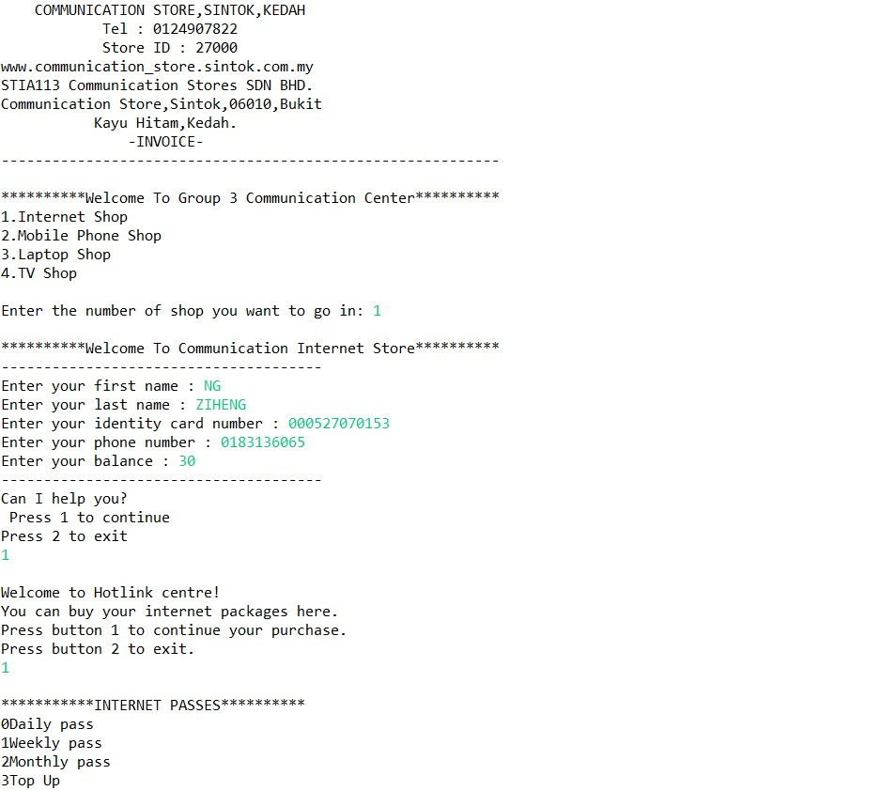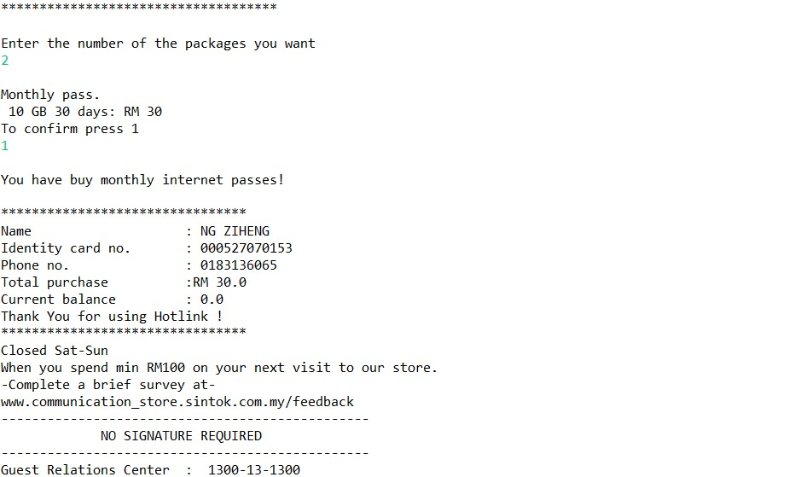

Mobile Phone Store

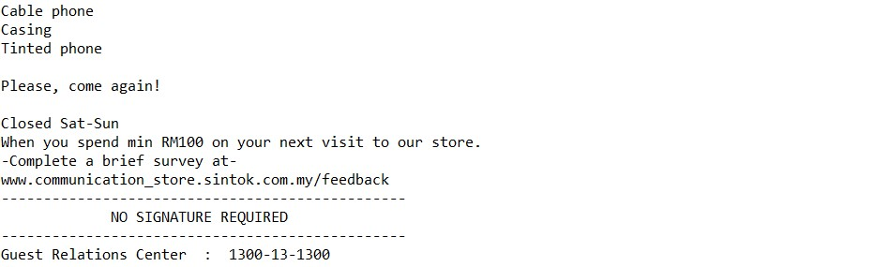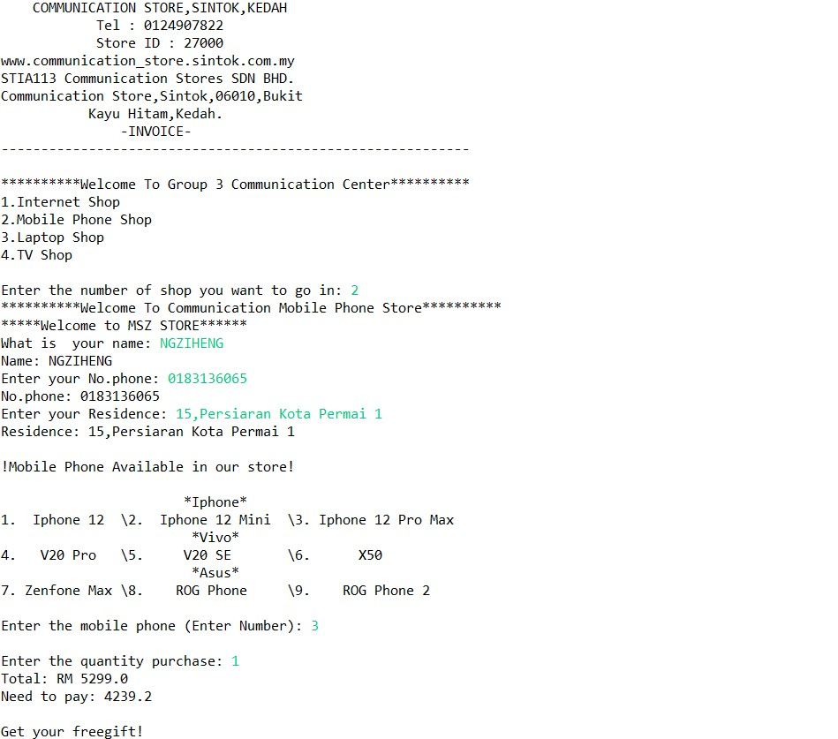

Laptop Store

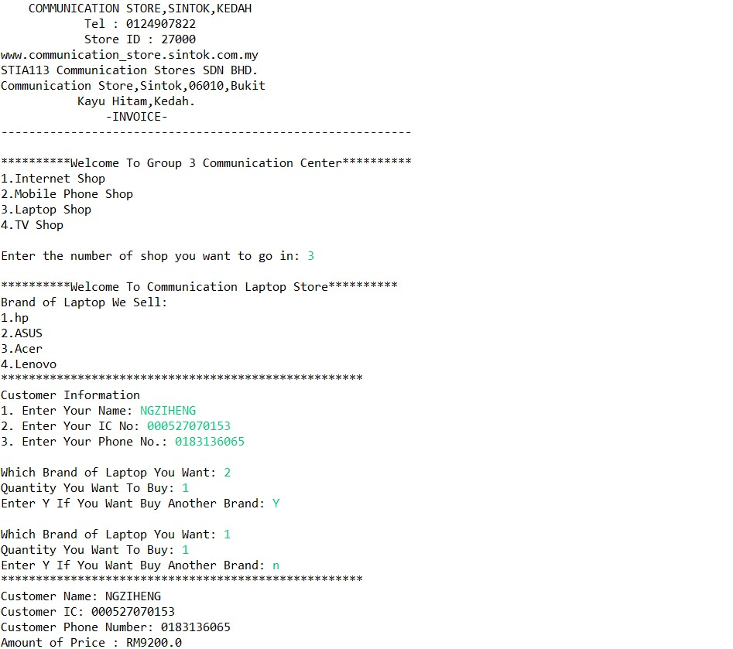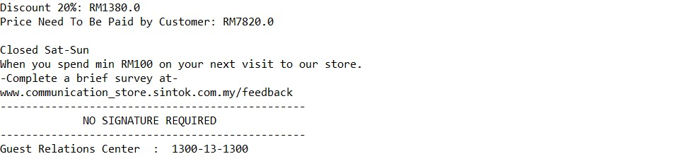

TV Store

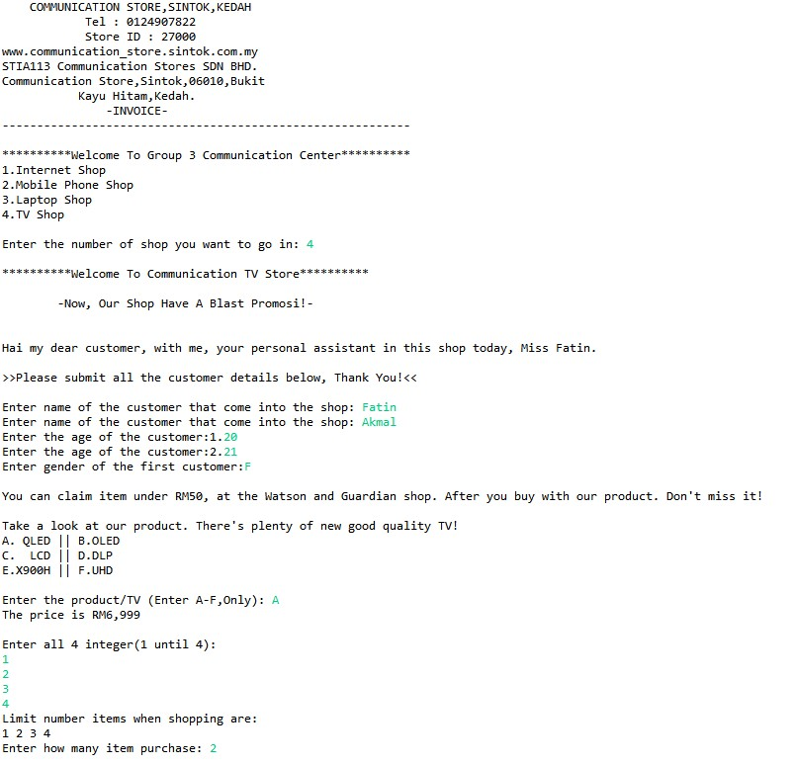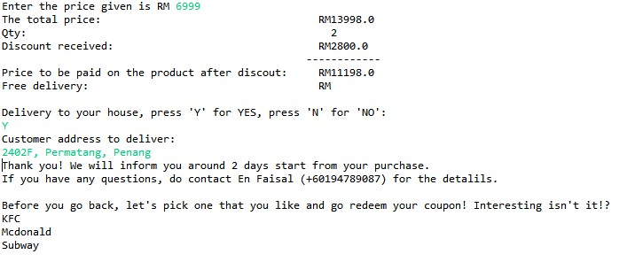

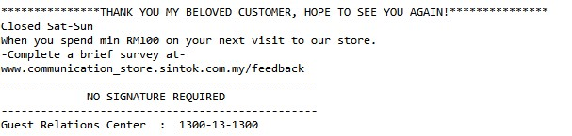

**6.0 References**

Alex Lee. (2019, Feb 8). While Loop Java Tutorial [Video file].

Retrieved from <https://www.youtube.com/watch?v=SGJ9DpxGCkY>

Alex Lee. (2018, Dec 7). Methods in Java Tutorial [Video file].

Retrieved from <https://www.youtube.com/watch?v=cCgOESMQe44>

Sam, S. (2018, January 9). How to pass Arrays to Methods in Java?

Tutorialspoint.Com. Retrieved from

[https://www.tutorialspoint.com/How-to-pass-Arrays-to-Methods-in- Java](https://www.tutorialspoint.com/How-to-pass-Arrays-to-Methods-in-%20%20%20%20Java)

Alex Lee. (2018, Oct 12). Array in Java Tutorial [Video file]. Retrieved from

<https://www.youtube.com/watch?v=xzjZy-dHHLw>

Alex Lee. (2018, Dec 21). if else in Java Tutorial [Video file]. Retrieved from

<https://www.youtube.com/watch?v=yvWnj_HfG6s>

Jakob Jenkov.(2015, March 3). Java Methods.Javatpoint. Retrieved from

<https://www.javatpoint.com/method-in-java>

Daniel, Y. L, (2011). Introduction to JAVA Programming. Comprehensive

Version, 10th Edition. Arsmtrong Atlantic State University. Pearson. *New*

*York.*

Software Testing.(18, January 2021). How to Pass / Return an Array in Java.

Retrieved from

<https://www.softwaretestinghelp.com/pass-return-array-in-java/>

Dinesh Thankur(2021). Passing arrays to methods in java. Retrieved from

<https://ecomputernotes.com/java/jarray/passing-arrays-to-methods>’

**Appendix: Coding, Internet store.**

**public** **static** **void** InternetShop() {

Scanner obj=**new** Scanner(System.***in***);

//array

String[] pass= {"Daily pass","Weekly pass","Monthly pass","Top Up"};

**double**[] price= {0,3,10,30};

//declare and initialize

**double** totalprice=0;

**double** current=0;

**double** value=0;

//input

System.***out***.println();

System.***out***.println("**********Welcome To Communication Internet Store**********");

//input

System.***out***.println("--------------------------------------");

System.***out***.print("Enter your first name : ");

String firstname=obj.next();

System.***out***.print("Enter your last name : ");

String lastname=obj.next();

System.***out***.print("Enter your identity card number : ");

String ic=obj.next();

System.***out***.print("Enter your phone number : ");

String hp=obj.next();

System.***out***.print("Enter your balance : ");

**double** balance=obj.nextDouble();

System.***out***.println("--------------------------------------");

System.***out***.println("Can I help you? ");

System.***out***.println(" Press 1 to continue");

System.***out***.println("Press 2 to exit ");

**int** c=obj.nextInt();

//If Else Statement

**if**(c==1) {

System.***out***.println();

System.***out***.println("Welcome to Hotlink centre!");

System.***out***.println("You can buy your internet packages here.");

System.***out***.println("Press button 1 to continue your purchase.");

System.***out***.println("Press button 2 to exit.");

**int** button=obj.nextInt();

**if**(button==1) {//enter

//menu

System.***out***.println();

System.***out***.println("***********INTERNET PASSES**********");

*displayListPass*(pass);

System.***out***.println("************************************");

System.***out***.println();

//input number pass

System.***out***.println("Enter the number of the packages you want");

**int** want=obj.nextInt();

//if choose daily press 0

**if**(want==0) {

System.***out***.println();

System.***out***.println("Daily pass.");

System.***out***.println(" 2 GB 1 day: RM 3");

System.***out***.println("To confirm press 1");

**int** press=obj.nextInt();

**if**(press==1) {

System.***out***.println();

**if**(balance>=3) {

System.***out***.println("You have buy daily internet passes!");

totalprice=price[1];

}

**else**

//method

*invalidPurchase*();

}

**else** {

System.***out***.println("You have canceled your purchase. ");

totalprice=price[0];

}

}

//if choose weekly press 1

**else** **if**(want==1) {

System.***out***.println();

System.***out***.println("Weekly pass.");

System.***out***.println(" 3 GB 7 days: RM 10");

System.***out***.println("To confirm press 1");

**int** press1=obj.nextInt();

**if**(press1==1) {

System.***out***.println();

**if**(balance>=10) {

System.***out***.println("You have buy weekly internet passes!");

totalprice=price[2];

}

**else**

//method

*invalidPurchase*();

}

**else** {

System.***out***.println("You have canceled your purchase. ");

totalprice=price[0];

}

}

//if choose monthly press 2

**else** **if**(want==2) {

System.***out***.println();

System.***out***.println("Monthly pass.");

System.***out***.println(" 10 GB 30 days: RM 30");

System.***out***.println("To confirm press 1");

**int** press2=obj.nextInt();

**if**(press2==1) {

System.***out***.println();

**if**(balance>=30) {

System.***out***.println("You have buy monthly internet passes!");

totalprice=price[3];

}//close if balance=30

**else** {//when balance not>=30

*invalidPurchase*();

}//close else if press2 not 1

}//close else when balance not>=30

**else** {

System.***out***.println("You have canceled your purchase. ");

totalprice=price[0];

}

//close else

}

**else** **if**(want==3) {//want 3

System.***out***.println();

System.***out***.println("Top Up");

System.***out***.println(".");

//Do While

**int** count=0;

**do** {

System.***out***.println("Enter the value you want to top up (RM 10-100");

System.***out***.print("RM");

value=obj.nextDouble();

System.***out***.println("Press 0 to check current balance");

**int** exit=obj.nextInt();

**if**(exit==0) {

count=1;

}

}**while**(count==0);

}//close want 3

**else** {//want other than 0,1,2,3

System.***out***.println();

System.***out***.println("You have canceled your purchase. ");

}//

System.***out***.println();

System.***out***.println("********************************");

System.***out***.println("Name\t\t\t: "+firstname+" " +lastname);

System.***out***.println("Identity card no. \t: "+ic);

System.***out***.println("Phone no. \t\t: "+hp);

System.***out***.println("Total purchase \t:RM "+totalprice);

current=balance-totalprice+value;

System.***out***.println("Current balance\t\t: "+current);

System.***out***.println("Thank You for using Hotlink !");

System.***out***.println("********************************");

}

**else** **if**(button==2){//button not =1

System.***out***.println("You have canceled your purchase. ");

}}

**else** **if**(c==2) {

System.***out***.println("You have canceled your purchase. ");

}

System.***out***.println("Closed Sat-Sun");

System.***out***.println("When you spend min RM100 on your next visit to our store.");

System.***out***.println("-Complete a brief survey at-");

System.***out***.println("www.communication_store.sintok.com.my/feedback");

System.***out***.println("------------------------------------------------");

System.***out***.println( " NO SIGNATURE REQUIRED ");

System.***out***.println("------------------------------------------------");

System.***out***.println("Guest Relations Center : 1300-13-1300");

}

**Appendix: Coding, Mobile phone store.**

**public** **static** **void** MobileShop() {

Scanner in = **new** Scanner (System.***in***);

String ip, vivo, asus;

String phone;

**int** quantity,price = 0;

**double** total,discount;

//Introduction to mobile phone store

System.***out***.println("**********Welcome To Communication Mobile Phone Store**********");

System.***out***.println("*****Welcome to MSZ STORE******");

//User input the details

System.***out***.print("What is your name: ");

String name = in.nextLine();

System.***out***.println("Name: " + name);

System.***out***.print("Enter your No.phone: ");

String num = in.nextLine();

System.***out***.println("No.phone: " + num);

System.***out***.print("Enter your Residence: ");

String residence = in.nextLine();

System.***out***.println("Residence: " + residence);

System.***out***.println();

//Mobile Available

System.***out***.println("!Mobile Phone Available in our store!");

//Using method

*PhoneList*();

System.***out***.println();

System.***out***.print("Enter the mobile phone (Enter Number): ");

String product = in.nextLine();

//Using If Else statement for user to choose the phone

**if**(product.equals("1")) {

price = 3899;

}

**else**

**if**(product.equals("2")) {

price = 3399;

}

**else**

**if**(product.equals("3")) {

price = 5299;

}

**else**

**if**(product.equals("4")) {

price = 1799;

}

**else**

**if**(product.equals("5")) {

price = 1019;

}

**else**

**if**(product.equals("6")) {

price = 1999;

}

**else**

**if**(product.equals("7")) {

price = 1099;

}

**else**

**if**(product.equals("8")) {

price = 3399;

}

**else**

**if**(product.equals("9")) {

price = 2499;

}

**else**

System.***out***.println("Non Available Product");

System.***out***.println();

System.***out***.print("Enter the quantity purchase: ");

quantity = in.nextInt();

//Numerical data & Expression

total = price * quantity;

System.***out***.println("Total: RM " +total);

//Using if else statement for discount

**if** (total >1000) {

discount = total*0.2;

}

**else** {

discount=(total*0.1);

}

//calculate for user to pay

System.***out***.println("Need to pay: " +(total-discount));

System.***out***.println();

//While loop

System.***out***.println("Get your freegift!");

String [] gift = {"Cable phone", "Casing", "Tinted phone"};

**int** a =0;

**while** (a<gift.length) {

System.***out***.println(gift[a]);

a++;

}

System.***out***.println();

//Passing Array To Method

String[] Array = *passing*();

**for**(**int** i=0; i<Array.length; i++) {

System.***out***.print(Array[i]+ " ");

}

System.***out***.println();

System.***out***.println();

System.***out***.println("Closed Sat-Sun");

System.***out***.println("When you spend min RM100 on your next visit to our store.");

System.***out***.println("-Complete a brief survey at-");

System.***out***.println("www.communication_store.sintok.com.my/feedback");

System.***out***.println("------------------------------------------------");

System.***out***.println( " NO SIGNATURE REQUIRED ");

System.***out***.println("------------------------------------------------");

System.***out***.println("Guest Relations Center : 1300-13-1300");

}

**Appendix: Coding, Laptop store.**

**public** **static** **void** LaptopShop() {

System.***out***.println();

//Introduction to Laptop store

System.***out***.println("**********Welcome To Communication Laptop Store**********");

Scanner in = **new** Scanner (System.***in***);

String[][] custInfo = **new** String [3][1];

**int**[] counter = {0,1,2};

*change*(counter);

**int** custLaptop;

**int** quantity=0;

**double** laptopprice = 0.00;

**double** totalprice=0.00;

**double** amount = 0.00;

**double** discount=0.00;

**char** next=0;

**double** pricetopaid=0.00;

//Method

*laptopBrand*();

//For loop

**for** (**int** i=0; i<52; i++) {

System.***out***.print("*");

}

//user input

System.***out***.println();

System.***out***.println("Customer Information");

System.***out***.print(counter[0] + ". Enter Your Name: ");

custInfo[0][0] = in.next();

System.***out***.print(counter[1] + ". Enter Your IC No: ");

custInfo[1][0] = in.next();

System.***out***.print(counter[2] + ". Enter Your Phone No.: ");

custInfo[2][0] = in.next();

**do**{

System.***out***.println();

System.***out***.print("Which Brand of Laptop You Want: ");

custLaptop = in.nextInt();

//If else statement for user to choose laptop

**if** (custLaptop == 1) {

laptopprice = 3600.00;

}

**else** **if** (custLaptop == 2) {

laptopprice = 5600.00;

}

**else** **if** (custLaptop == 3) {

laptopprice = 4500.00;

}

**else** **if** (custLaptop == 4) {

laptopprice = 2800.00;

}

**else** **if** (custLaptop >=5) {

System.***out***.print("Invalid");

}

System.***out***.print("Quantity You Want To Buy: ");

quantity = in.nextInt();

//numerical Data & expression

totalprice = laptopprice * quantity;

amount = amount + totalprice;

**if** (amount >= 2500 && amount < 5000) {

discount = amount * 0.05;

}

**else** **if** (amount >= 5000 && amount <= 7500) {

discount = amount * 0.10;

}

**else** **if** (amount >= 7500 && amount <= 10000) {

discount = amount * 0.15;

}

**else** **if** (amount > 10000) {

discount = amount * 0.20;

}

pricetopaid = amount - discount;

System.***out***.print("Enter Y If You Want Buy Another Brand: ");

next = in.next().charAt(0);

} **while** (next == 'Y' || next == 'y');

**int** i=0;

**while** (i<52) {

System.***out***.print("*");

i++;

}

System.***out***.println();

System.***out***.println("Customer Name: " + custInfo[0][0]);

System.***out***.println("Customer IC: " + custInfo[1][0]);

System.***out***.println("Customer Phone Number: " + custInfo[2][0]);

System.***out***.println("Amount of Price : RM" + amount);

System.***out***.println("Discount 20%: RM" + discount);

System.***out***.println("Price Need To Be Paid by Customer: RM" + pricetopaid);

System.***out***.println();

System.***out***.println("Closed Sat-Sun");

System.***out***.println("When you spend min RM100 on your next visit to our store.");

System.***out***.println("-Complete a brief survey at-");

System.***out***.println("www.communication_store.sintok.com.my/feedback");

System.***out***.println("------------------------------------------------");

System.***out***.println( " NO SIGNATURE REQUIRED ");

System.***out***.println("------------------------------------------------");

System.***out***.println("Guest Relations Center : 1300-13-1300");

}

**Appendix: Coding, TV store.**

**public** **static** **void** TVShop() {

Scanner in = **new** Scanner (System.***in***);

String name,TV;

**int** age,price,item,cust;

**char** gender;

**double** discount, total;

//Introduction to TV store

System.***out***.println();

System.***out***.println("**********Welcome To Communication TV Store**********");

System.***out***.println();

System.***out***.println(" -Now, Our Shop Have A Blast Promosi!- ");

System.***out***.println();

//Array 2D

//column 0 and 1

//row 0,1,2

String [][] myname = {{"Mrs", "Mr", "Miss"},

{"Fatin", "Akmal", "Rajh"}

};

System.***out***.println();

System.***out***.println("Hai my dear customer, with me, your personal assistant in this shop today, " +myname[0][2]+ " " +myname [1][0]+ ".");

System.***out***.println();

System.***out***.println(">>Please submit all the customer details below, Thank You!<<");

System.***out***.println();

//FOR LOOP

**for**(**int** i=0; i < 2;i++) {

System.***out***.print("Enter name of the customer that come into the shop: ");

name = in.next();

}

//DO-WHILE LOOP

**int** x =1;

**do** {

System.***out***.print("Enter the age of the customer:"+x+ ".");

age = in.nextInt();

x++;

}

**while**(x<3);

System.***out***.print("Enter gender of the first customer:" );

gender = in.next().charAt(0);

System.***out***.println();

//REPETITION STRUCTURE (IF/ELSE) FOR GENDER

**if**(gender=='F') {

System.***out***.println("You can claim item under RM50, at the Watson and Guardian shop. After you buy with our product. Don't miss it!");

}

**else**

**if**(gender=='M') {

System.***out***.println("You can claim item under RM50, at the electric shop. After you buy with our product. Don't miss it!");

}

**else**

System.***out***.println("None");

System.***out***.println();

//Array

System.***out***.println("Take a look at our product. There's plenty of new good quality TV!");

String[][] product_1 = {

{"A. QLED", "B.OLED"},

{"C. LCD", "D.DLP"},

{"E.X900H", "F.UHD"}

};

**for** (**int** i = 0; i < product_1.length; i++)

{

System.***out***.print( product_1[ i ] [ 0 ] + " || " );

**for** (**int** j = 1; j < product_1[ i ].length; j++)

{

System.***out***.print( product_1[ i ][ j ] + " ");

}

System.***out***.print("\n");

}

System.***out***.println();

System.***out***.print("Enter the product/TV (Enter A-F,Only): ");

String product = in.next();

**if**(product.equals("A")) {

System.***out***.println("The price is RM6,999");

}

**else**

**if**(product.equals("B")) {

System.***out***.println("The price is RM8,999");

}

**else**

**if**(product.equals("C")) {

System.***out***.println("The price is RM5,599");

}

**else**

**if**(product.equals("D")) {

System.***out***.println("The price is RM1,940");

}

**else**

**if**(product.equals("E")) {

System.***out***.println("The price is RM4,469");

}

**else**

**if**(product.equals("F")) {

System.***out***.println("The price is RM2,090");

}

**else**

System.***out***.println("None product available, we are sorry!");

System.***out***.println();

//passing method

//how many item that customer purchase

**final** **int** SIZE = 4; //size array

**int**[] num_array = **new** **int**[SIZE];

//passing array

*fillArray*(num_array, SIZE);

System.***out***.println("Limit number items when shopping are: ");

*printArray*(num_array, SIZE);

System.***out***.println();

System.***out***.print("Enter how many item purchase: ");

item = in.nextInt();

System.***out***.println();

//calculate the total price

System.***out***.print("Enter the price given is RM ");

price = in.nextInt();

total = price * item;

System.***out***.println("The total price: RM" +total);

System.***out***.println("Qty: " +item);

//discount

**if**(total<1000) {

discount =Math.*round*(total * 0.1);

}

**else**

discount =Math.*round*(total * 0.2);

System.***out***.println("Discount received: RM" +discount);

System.***out***.println(" ------------");

System.***out***.println("Price to be paid on the product after discout: RM"+(total-discount));

System.***out***.println("Free delivery: RM ");

System.***out***.println();

System.***out***.println("Delivery to your house, press 'Y' for YES, press 'N' for 'NO':");

**char** delivery = in.next().charAt(0);

**if**(delivery=='Y') {

System.***out***.println("Customer address to deliver: ");

String address = in.next();

System.***out***.println("Thank you! We will inform you around 2 days start from your purchase.");

System.***out***.println("If you have any questions, do contact En Faisal (+60194789087) for the detalils.");

}

**else** {

**if**(delivery=='N') {

System.***out***.println("Thank you for the confirmation! Have a nice day.");

}

}

System.***out***.println();

//WHILE LOOP

System.***out***.println("Before you go back, let's pick one that you like and go redeem your coupon! Interesting isn't it!?");

//Single Array

String[] array1 = **new** String[] {"KFC", "Mcdonald", "Subway"};

//iterating all elements in the array

**for**(**int** i=0; i< array1.length; i++) {

System.***out***.println(array1[i]);

}

System.***out***.println();

System.***out***.println("***************THANK YOU MY BELOVED CUSTOMER, HOPE TO SEE YOU AGAIN!***************");

System.***out***.println("Closed Sat-Sun");

System.***out***.println("When you spend min RM100 on your next visit to our store.");

System.***out***.println("-Complete a brief survey at-");

System.***out***.println("www.communication_store.sintok.com.my/feedback");

System.***out***.println("------------------------------------------------");

System.***out***.println( " NO SIGNATURE REQUIRED ");

System.***out***.println("------------------------------------------------");

//Method

*guest*();

}